ECE 313 Lecture Notes
Lecture 5 on Sampling & Reconstruction Part 1
Thursday, September 24, 2026
By TA Alice Liu
…
Audio Effects: Post Malone, "Circles", demonstrating use of delay, chorusing, and reverb in the vocals, and delay and reverb in the instruments. Play "Circles" starting at 34 seconds and ending at 60 seconds. "Vocal Effects of Post Malone - Circles".
- Reverb
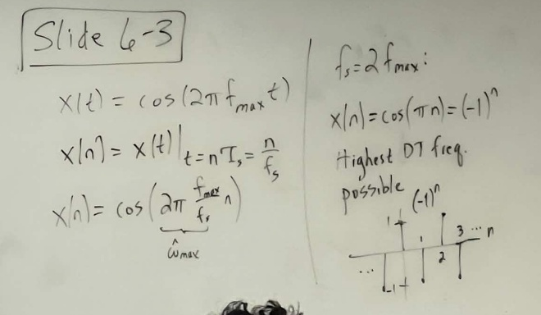
- Chorusing
- Vibrato
…
Sampling Theorem
- Nyquist Rate = $2f_{max}$
- Nyquist Frequency = $\frac{1}{2}f_{s}$
Sampling & Reconstruction Demo
- Rectangular Pulse/Sample-and-Hold
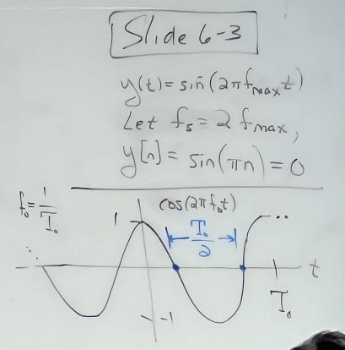
  - Captures the cosine frequency correctly!
  - Doesn’t match the original signal’s shape very well…
- What if we increase $f_{s}$?
  - More samples per period
  - Still captures the fundamental frequency
  - Better matching of peaks/valleys/zero-crossings
  - Increasing $f_{s}$ allows for better reconstruction of the actual signal but at a tradeoff of more samples per second and high run-time implementation complexity
Sampling of Discrete-Time Signal
- Given a sampling frequency, $f_{s}$, and a signal, $x$, that has frequency components equal to or greater than $f_{max}=\frac{1}{2}f_{s}$, how should we sample appropriately?
  - In order to maintain the Sampling Theorem, we should filter out higher frequency components
  - In other words, we should lowpass filter signal, $x$, to attenuate all frequency components greater than or equal to $f_{max}$ (not possible to remove them)
Oversampling
- Oversample to avoid aliasing & folding effects
Undersampling
- Shifted versions of the aliased frequency
- But in Reconstruction, for this Example: we only see frequencies within $[-π,π]$
  - This is because of the Sampling Theorem for Reconstruction
Folding by Undersampling
- Negative frequency component aliases towards positive frequency
- Positive frequency component aliases towards negative frequency
Demonstration of the Above 3 Effects <http://www.youtube.com/watch?v=uENITui5_jU&feature=share>
